Lab 9: Database Design Basics

Part 1. Setup

Step 1. Create a schema for this lab
DROP SCHEMA IF EXISTS lab9 CASCADE;
CREATE SCHEMA lab9;
SET search_path TO lab9;

Part 2. Normalization

Step 2. Table that violates 1NF
The courses column holds a list of values, so it is not atomic.
CREATE TABLE students_not_1nf (
student_id INTEGER PRIMARY KEY,
name VARCHAR(100),
courses TEXT
);
INSERT INTO students_not_1nf VALUES
(1, 'Zhamilya Kambaraalieva', 'Databases, Algorithms, Web Development'),
(2, 'Aibek Toktorov', 'Databases, Calculus');
SELECT * FROM students_not_1nf;
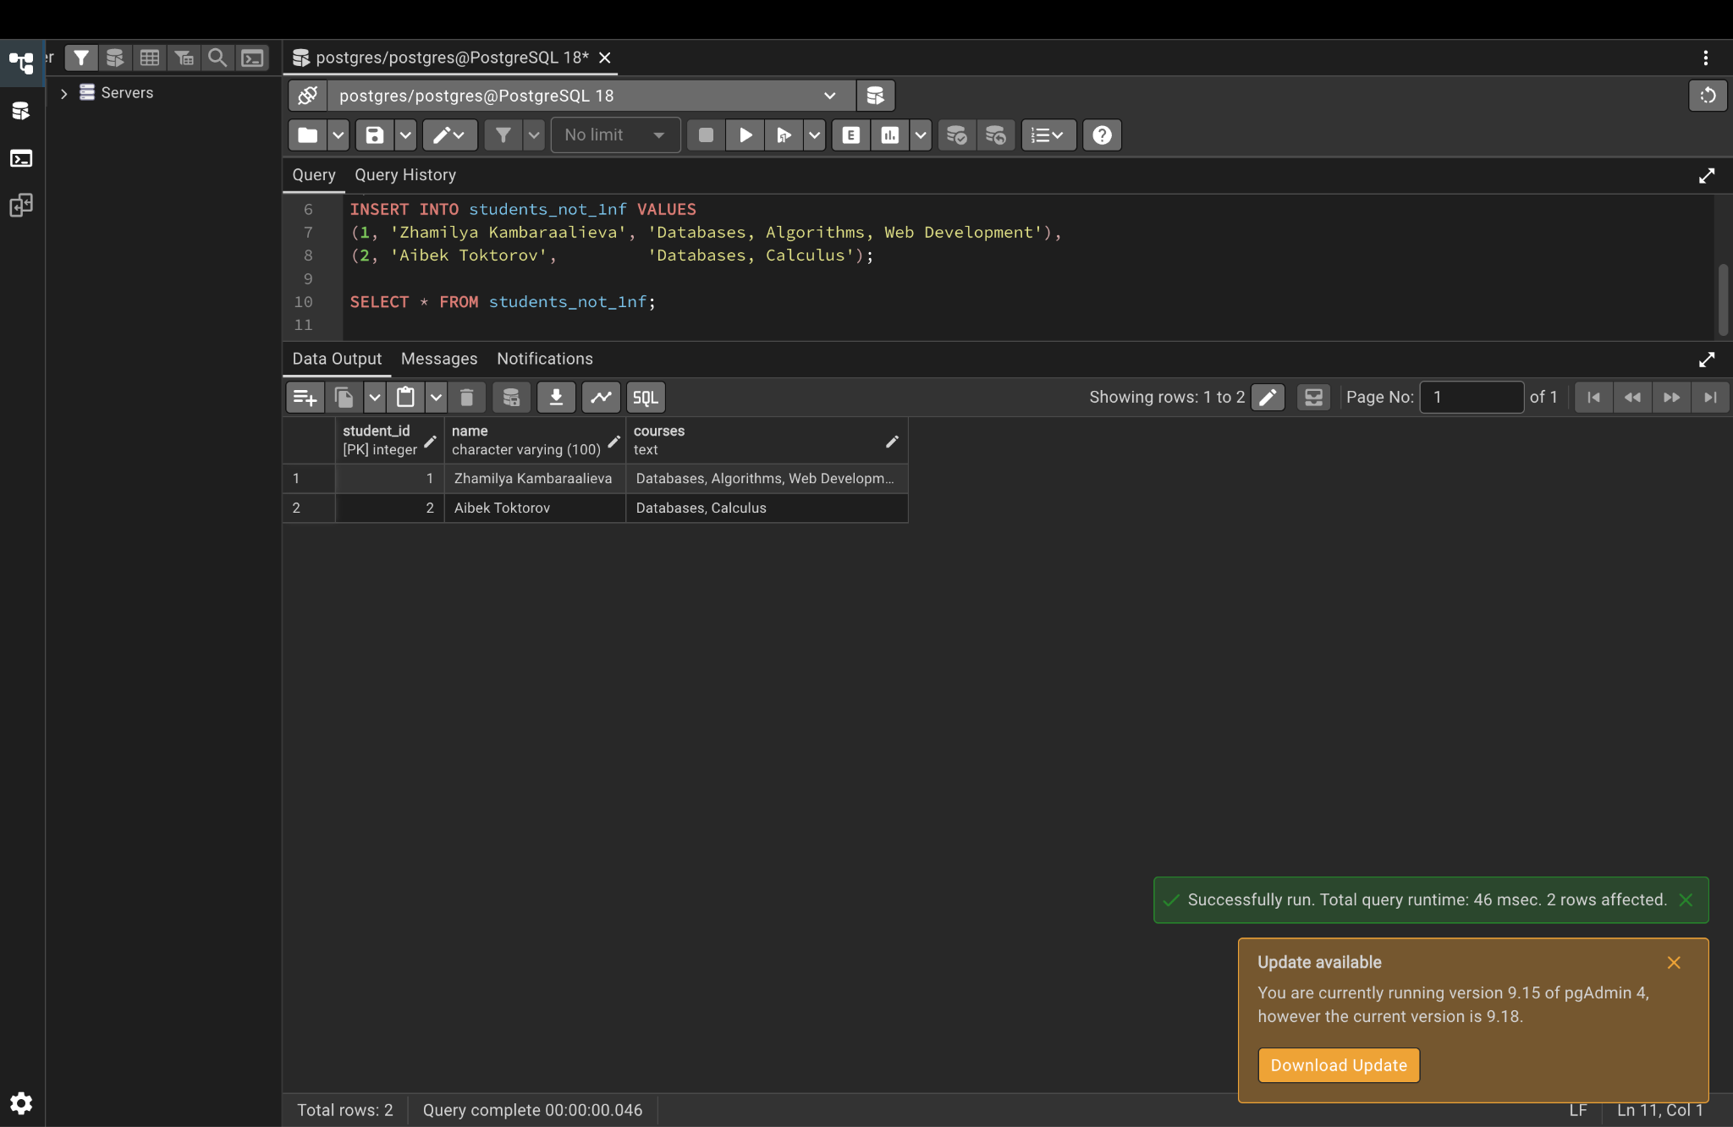

Step 3. Fix it: table in 1NF
One value per cell, one row per student-course pair.
CREATE TABLE students_1nf (
student_id INTEGER,
name VARCHAR(100),
course VARCHAR(100),
PRIMARY KEY (student_id, course)
);
INSERT INTO students_1nf VALUES
(1, 'Zhamilya Kambaraalieva', 'Databases'),
(1, 'Zhamilya Kambaraalieva', 'Algorithms'),
(1, 'Zhamilya Kambaraalieva', 'Web Development'),
(2, 'Aibek Toktorov', 'Databases'),
(2, 'Aibek Toktorov', 'Calculus');
SELECT * FROM students_1nf;
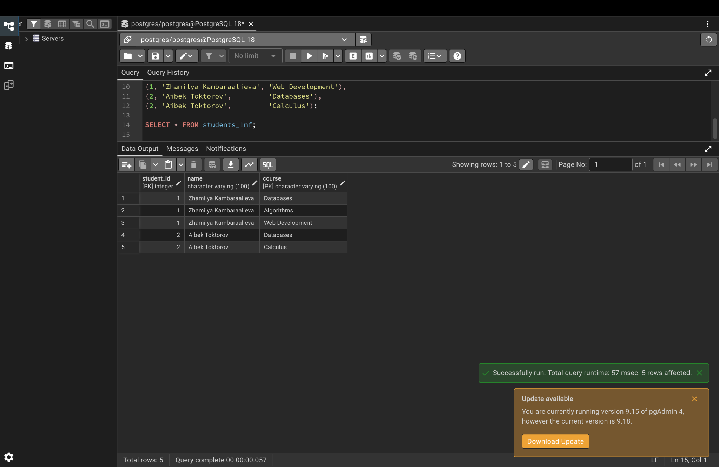

Step 4. Table that violates 2NF
The key is (student_id, course_id), but student_name depends only on student_id and course_name only on course_id. That is a partial dependency, so names repeat.
CREATE TABLE enrollments_not_2nf (
student_id INTEGER,
course_id INTEGER,
student_name VARCHAR(100),
course_name VARCHAR(100),
grade CHAR(2),
PRIMARY KEY (student_id, course_id)
);
INSERT INTO enrollments_not_2nf VALUES
(1, 101, 'Zhamilya Kambaraalieva', 'Databases', 'A'),
(1, 102, 'Zhamilya Kambaraalieva', 'Algorithms', 'A-'),
(2, 101, 'Aibek Toktorov', 'Databases', 'B+');
SELECT * FROM enrollments_not_2nf;
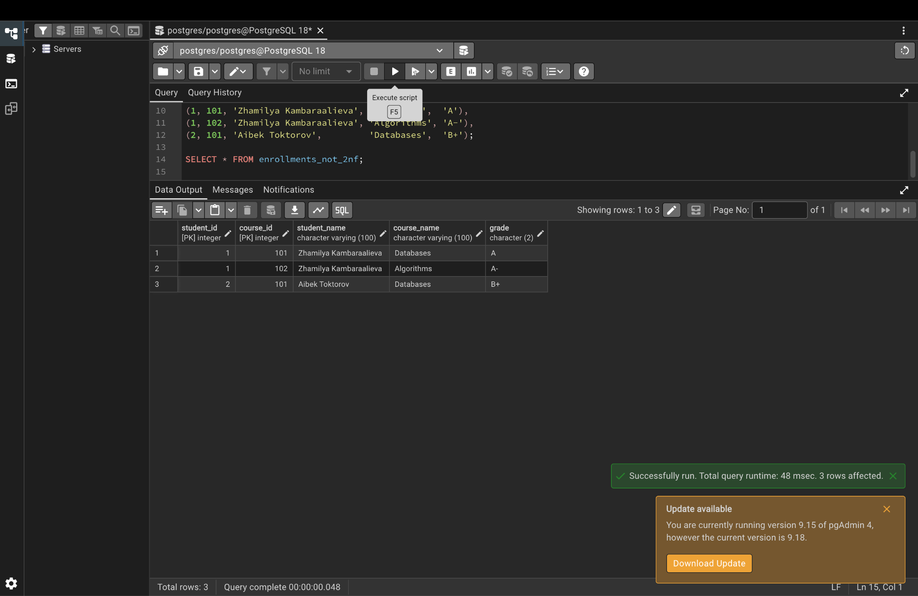

Step 5. Table that violates 3NF
department_name and building depend on department_id, not on professor_id. That is a transitive dependency.
CREATE TABLE professors_not_3nf (
professor_id INTEGER PRIMARY KEY,
name VARCHAR(100),
department_id INTEGER,
department_name VARCHAR(100),
building VARCHAR(50)
);
INSERT INTO professors_not_3nf VALUES
(1, 'Dr. Ivanov', 10, 'Computer Science', 'Block A'),
(2, 'Dr. Sydykova', 10, 'Computer Science', 'Block A'),
(3, 'Dr. Asanov', 20, 'Mathematics', 'Block B');
SELECT * FROM professors_not_3nf;
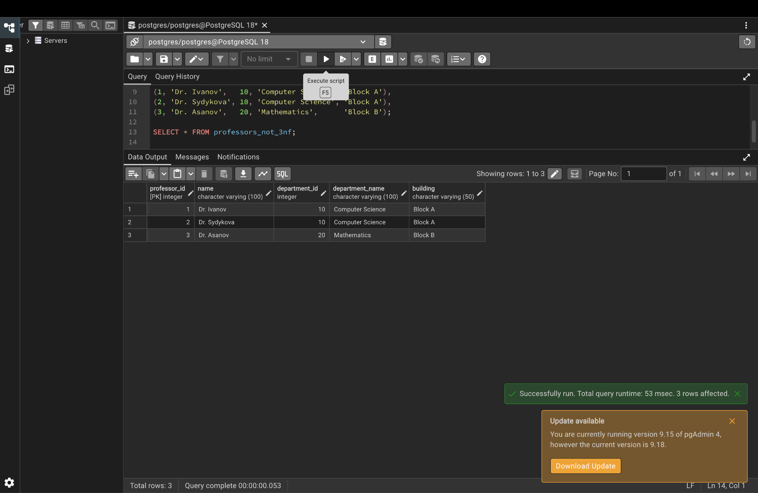

Part 3. University database in 3NF (the ER example)

Step 6. Create the normalized tables
Entities: Department, Professor, Student, Course. Relationships: a professor teaches many courses (one-to-many), students enroll in many courses (many-to-many). Address is a composite attribute split into street, city and zip_code.
CREATE TABLE departments (
department_id SERIAL PRIMARY KEY,
department_name VARCHAR(100) NOT NULL UNIQUE,
building VARCHAR(50)
);
CREATE TABLE professors (
professor_id SERIAL PRIMARY KEY,
name VARCHAR(100) NOT NULL,
email VARCHAR(150) UNIQUE,
department_id INTEGER REFERENCES departments(department_id)
);
CREATE TABLE students (
student_id SERIAL PRIMARY KEY,
first_name VARCHAR(50) NOT NULL,
last_name VARCHAR(50) NOT NULL,
email VARCHAR(150) UNIQUE NOT NULL,
date_of_birth DATE,
street VARCHAR(100),
city VARCHAR(50),
zip_code VARCHAR(10)
);
CREATE TABLE courses (
course_id SERIAL PRIMARY KEY,
course_name VARCHAR(100) NOT NULL,
credits INTEGER CHECK (credits > 0),
professor_id INTEGER REFERENCES professors(professor_id)
);
CREATE TABLE enrollments (
student_id INTEGER REFERENCES students(student_id),
course_id INTEGER REFERENCES courses(course_id),
grade CHAR(2),
PRIMARY KEY (student_id, course_id)
);

Step 7. Insert data
INSERT INTO departments (department_name, building) VALUES
('Computer Science', 'Block A'), ('Mathematics', 'Block B');
INSERT INTO professors (name, email, department_id) VALUES
('Dr. Ivanov', 'ivanov@alatoo.edu.kg', 1),
('Dr. Sydykova', 'sydykova@alatoo.edu.kg', 1),
('Dr. Asanov', 'asanov@alatoo.edu.kg', 2);
INSERT INTO students (first_name, last_name, email, date_of_birth, street, city, zip_code) VALUES
('Zhamilya', 'Kambaraalieva', 'zhamilya@alatoo.edu.kg', '2005-03-14', 'Chui Ave 10', 'Bishkek', '720001'),
('Aibek', 'Toktorov', 'aibek@alatoo.edu.kg', '2004-11-02', 'Manas Ave 5', 'Bishkek', '720010'),
('Aigerim', 'Asanova', 'aigerim@alatoo.edu.kg', '2005-07-21', 'Lenin St 12', 'Osh', '723500');
INSERT INTO courses (course_name, credits, professor_id) VALUES
('Databases', 5, 1), ('Algorithms', 5, 2), ('Calculus', 4, 3);
INSERT INTO enrollments VALUES
(1, 1, 'A'), (1, 2, 'A-'), (2, 1, 'B+'), (2, 3, 'B'), (3, 2, 'A');

Step 8. Show that the 2NF and 3NF problems are gone
Names and departments are stored once and brought back with JOINs.
-- Fixes the 2NF example
SELECT s.first_name || ' ' || s.last_name AS student, c.course_name, e.grade
FROM enrollments e
JOIN students s ON e.student_id = s.student_id
JOIN courses c ON e.course_id = c.course_id
ORDER BY student;
-- Fixes the 3NF example
SELECT p.name AS professor, d.department_name, d.building
FROM professors p JOIN departments d ON p.department_id = d.department_id;
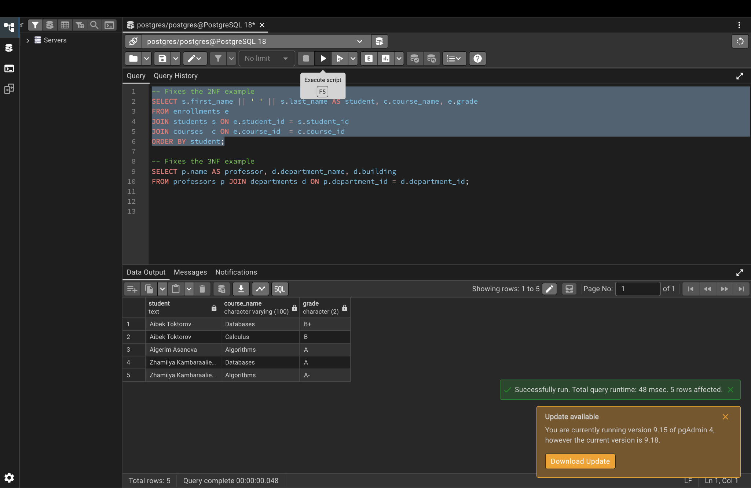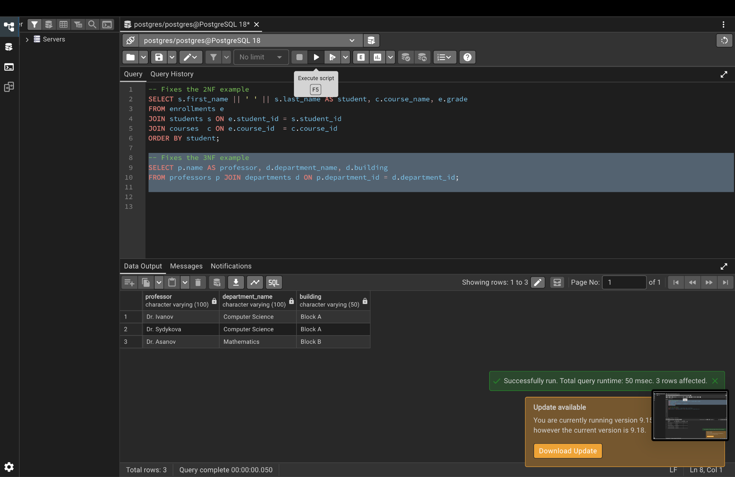

Step 9. Derived attribute: age
Age is not stored. It is calculated from date_of_birth.
SELECT first_name, last_name, date_of_birth,
DATE_PART('year', AGE(date_of_birth)) AS age,
street || ', ' || city || ' ' || zip_code AS full_address
FROM students;
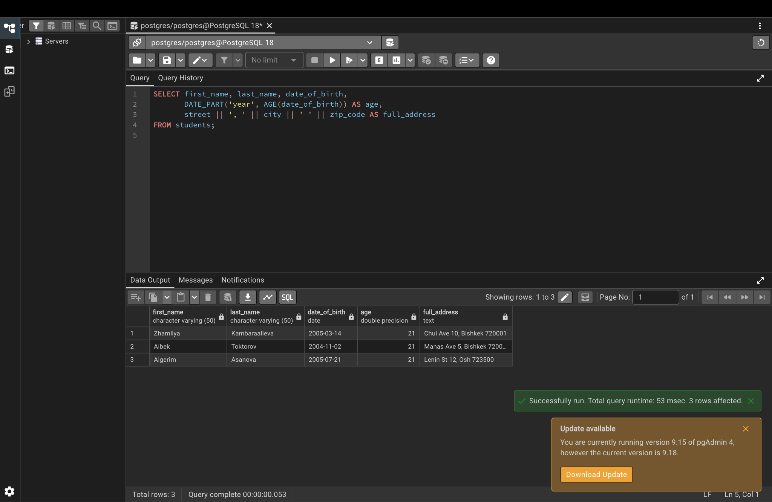

Part 4. Design example: Library Management System

Step 10. Logical design: create the tables
Entities: Author, Book, Member, Loan. Author writes Book is many-to-many (book_authors). Member borrows Book through Loan.
CREATE TABLE authors (
author_id SERIAL PRIMARY KEY,
first_name VARCHAR(50) NOT NULL,
last_name VARCHAR(50) NOT NULL
);
CREATE TABLE books (
book_id SERIAL PRIMARY KEY,
title VARCHAR(200) NOT NULL,
isbn VARCHAR(20) UNIQUE,
published_year INTEGER,
copies INTEGER DEFAULT 1 CHECK (copies >= 0)
);
CREATE TABLE book_authors (
book_id INTEGER REFERENCES books(book_id) ON DELETE CASCADE,
author_id INTEGER REFERENCES authors(author_id) ON DELETE CASCADE,
PRIMARY KEY (book_id, author_id)
);
CREATE TABLE members (
member_id SERIAL PRIMARY KEY,
first_name VARCHAR(50) NOT NULL,
last_name VARCHAR(50) NOT NULL,
email VARCHAR(150) UNIQUE NOT NULL,
joined_date DATE DEFAULT CURRENT_DATE
);
CREATE TABLE loans (
loan_id SERIAL PRIMARY KEY,
book_id INTEGER NOT NULL REFERENCES books(book_id),
member_id INTEGER NOT NULL REFERENCES members(member_id),
loan_date DATE NOT NULL DEFAULT CURRENT_DATE,
due_date DATE NOT NULL,
return_date DATE,
CHECK (due_date >= loan_date)
);
CREATE INDEX idx_loans_member ON loans(member_id); -- physical design: index

Step 11. Insert library data
INSERT INTO authors (first_name, last_name) VALUES
('Chingiz', 'Aitmatov'), ('Abraham', 'Silberschatz'), ('Henry', 'Korth');
INSERT INTO books (title, isbn, published_year, copies) VALUES
('Jamilia', '978-0001', 1958, 3),
('The White Ship', '978-0002', 1970, 2),
('Database System Concepts', '978-0003', 2019, 5);
INSERT INTO book_authors VALUES (1, 1), (2, 1), (3, 2), (3, 3);
INSERT INTO members (first_name, last_name, email) VALUES
('Zhamilya', 'Kambaraalieva', 'zhamilya@alatoo.edu.kg'),
('Aibek', 'Toktorov', 'aibek@alatoo.edu.kg');
INSERT INTO loans (book_id, member_id, loan_date, due_date, return_date) VALUES
(1, 1, '2026-09-01', '2026-09-15', '2026-09-14'),
(3, 1, '2026-10-01', '2026-10-10', NULL),
(2, 2, '2026-10-05', '2026-10-12', NULL);

Step 12. Query the library
Books with all their authors, and overdue loans with a late fee of 10 som per day (a derived value).
SELECT b.title, STRING_AGG(a.first_name || ' ' || a.last_name, ', ') AS authors
FROM books b
JOIN book_authors ba ON b.book_id = ba.book_id
JOIN authors a ON ba.author_id = a.author_id
GROUP BY b.title;
SELECT m.first_name || ' ' || m.last_name AS member, b.title, l.due_date,
CURRENT_DATE - l.due_date AS days_late,
(CURRENT_DATE - l.due_date) * 10 AS late_fee_som
FROM loans l
JOIN members m ON l.member_id = m.member_id
JOIN books b ON l.book_id = b.book_id
WHERE l.return_date IS NULL AND l.due_date < CURRENT_DATE;
